
a
Company
Logotype

Cone Beam Computed Tomography- Report



Porur Dental X-rays & CBCT

Patient Name : Mr. Kingston | Date of Report : 14.07.2024
Age/ Gender : 37 years/ Male | Region of Interest : CBCT Sectional Maxilla
Referring doctor: Dr. S.M.M. Moulvi | Indication : Implant assessment
Clinical Notes: Nil
PATIENT INFORMATION

CBCT- Sectional Maxilla provided
CBCT – IMAGE DETAILS

RADIOGRAPHIC INTERPRETATION

- Completely missing crown and root portion in relation to: 15.
- The maxillary alveolar ridge is present with normal trabecular pattern.
- In relation to 36, presence of hyperdense restorative material within the pulp canals extending upto the apical third of the roots is evident. Presence of mild hypodensity in the furcation region is also evident.
 | 15 region
Sub-Crestal (in mm) | 4.6
Mid- Crestal (in mm) | 7.3
Distance between the alveolar ridge and floor of the maxillary sinus (in mm) | 11.9
IMPLANT ASSESSMENT
RADIOGRAPHIC IMPRESSION

- Partially edentulous maxillary arch.
- Root canal treated tooth: 36.

Kindly correlate with clinical findings


IMAGES FOR REFERENCE

RECONSTRUCTED PANORAMIC VIEW
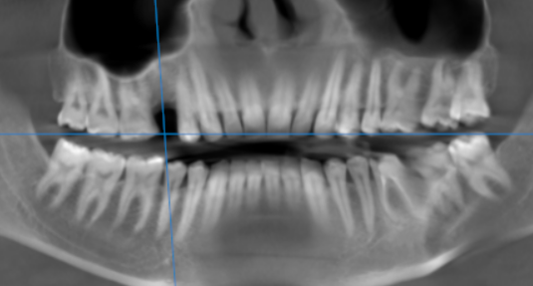

3-DIMENSIONAL VIEW
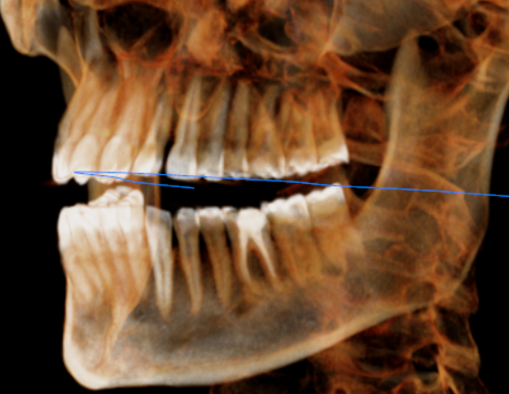
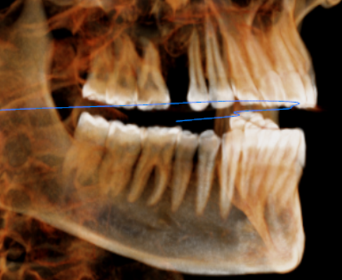

CROSS SECTIONAL VIEW

15 region | 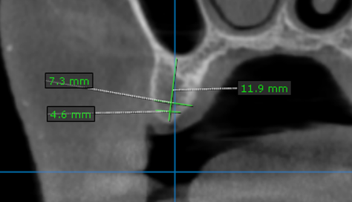

**** End of report ****

